**Curriculum Vita**

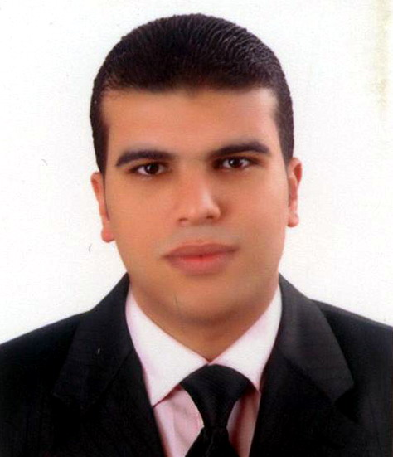

**Personal Profile:**

* **Name *: Mohamed Fathi Abdelrahman***
* **Date of Birth  *: 01\09\1986***
* **Place of Birth *: Egypt... Mansoura .***
* **Nationality *: Egyptian.***
* **Marital Status *: Married .***
* **Residence *:*A valid residence in U.A.E valid**

**for 2021 .**

**Academic education:**

* **Qualification :*Bachelor of Specific Education .***
* **Academy :*Faculty of Specific Education .***
* **Department : *Department of Music .***
* **Year of Graduation : *2009.***

**Language Abilities:**

* **Arabic : *Mother tongue.***
* **English : *good command of English Language***

***(Speaking – writing – reading).***

**Previous Experiences:**

* **Worked in Zoom co. for computer & network services for 2 years from 2009 to 2011.**
* **Worked for Al - Saied Trading & Real Estate Investment Estes an Secretary and Document Controller & ( Sales & Marketing ) for 6 years from 2011 to 2017 ( Egypt ) .**
* **Worked for Tasaheel Company for improving small businesses (Microfinance Company) as a Personal & Projects loans specialist for 2 years from 2017 to 2019 ( Egypt ) .**
* **Worked for Trans Continents Company Real Estate Management & Construction as secretary and office management & Debt collection * UAE**

***During my work duration I have practiced on:***

* **Have very good speed in both Arabic & English Typing.**
* **Have good experience in Persuading.**
* **Have very good experience in dealing with customers.**
* **Have very good computer experience ( word & excel ).**
* **Have very good experience in administrative works*.***

**Personal Features:**

* **Good presentation & looking, self-confident and fluent.**
* **Ambitious, hard-worker, honest, sociable and dependable.**
* **Ability to adapt well to changes and work under stress.**
* **Having good communication and persuasion skills.**

**Contact Information:**

**Address *:*21st - Murabbaa - Ain Mall - Al Ain City - UAE**

**Tel. :** (Mobile) +971 56 303 1517

**E-mail :Mohamedfathyghonaim@gmail.com**

**Thanks a Lot for Paying Attention**